|  |  |
| --- | --- |
| **Assignment** | |
| **Course Code** | CSC401A |
| **Course Name** | Computational Intelligence |
| **Programme** | B.Tech |
| **Department** | CSE |
| **Faculty** | FET |

|  |  |
| --- | --- |
| **Name of the Student** | Satyajit Ghana |
| **Reg. No.** | 17ETCS002159 |
| **Semester/Year** | 07/2021 |
| **Course Leader(s)** | Mr. Sagar U |



|  |  |  |  |  |  |  |  |  |
| --- | --- | --- | --- | --- | --- | --- | --- | --- |
| Declaration Sheet | | | | | | | | |
| Student Name | Satyajit Ghana | | | | | | | |
| Reg. No | 17ETCS002159 | | | | | | | |
| Programme | B.Tech | | | | | Semester/Year | 07/2021 | |
| Course Code | CSC401A | | | | | | | |
| Course Title | Computational Intelligence | | | | | | | |
| Course Date |  | | to |  | | | | |
| Course Leader | Mr. Sagar U | | | | | | | |
| **Declaration**  The assignment submitted herewith is a result of my own investigations and that I have conformed to the guidelines against plagiarism as laid out in the Student Handbook. All sections of the text and results, which have been obtained from other sources, are fully referenced. I understand that cheating and plagiarism constitute a breach of University regulations and will be dealt with accordingly. | | | | | | | | |
| Signature of the Student | |  | | | | | Date |  |
| Submission date stamp  (by Examination & Assessment Section) | |  | | | | | | |
| Signature of the Course Leader and date | | | | | Signature of the Reviewer and date | | | |
|  | | | | |  | | | |

# Contents

Declaration Sheet ii

Contents iii

List of Figures iv

1 Question 1 5

1.1 A critical review of cognitive abilities of ANNs 5

1.2 The application areas in which ANNs have been successful in delivering human-like performance 7

1.3 Conclusion 10

2 Question 2 12

2.1 A model of generalized fuzzy decision system for project evaluation 12

2.2 Fuzzy sets with attributes 16

2.3 Dataset (test cases) generation 22

2.4 Fuzzy Logic System Creation 23

2.5 Evaluating Student Performance 26

2.6 Results 33

Bibliography 35

Appendix 36

# List of Figures

Figure 1 Retinotopic Mapping of a Cat's Cortex 5

Figure 2 An electrical equivalent of the biological neuron 6

Figure 3 Deep Learning based Self Driving Car 8

Figure 4 Pixel Restoration 8

Figure 5 Machine Translation example from GPT3 10

# Question 1

Solution to Question No. 1 Part A

## A critical review of cognitive abilities of ANNs

*“… neural networks, genetic algorithms, fuzzy systems, evolutionary programming and artificial life are the building blocks of computational intelligence.” – Marks*

While the processing element in an artificial neural network (ANN) is generally considered to be the very roughly analogous to a biological neuron, the cell body in an ANN is modeled by a linear activation function. The activation function in general, attempts to enhance the signal contribution received through different dendrons.

But how do we know that our human neuron system uses a firing function to start the neural process? There was this Retinotopic Mapping performed on a Cat, basically a cat was strapped to a place, and the brain was injected with a radioactive fluid, now an image was shown to the cat, and it was killed as soon as the cat saw the image, the cat’s brain was laid out flat and X-Ray was taken of it, to a surprise the image had a complete print over the brain, as shown below,

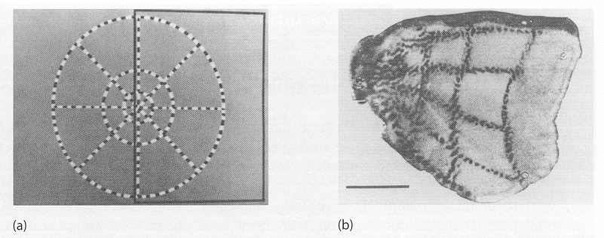

Figure Retinotopic Mapping of a Cat's Cortex

This experiment paved the way that Neural Networks would be the future of Artificial Intelligence, even in our modern neural network architectures for computer vision specifically, the entire input image is fed to the network, and several convolutions are performed to make sense of the input and get some meaningful output.

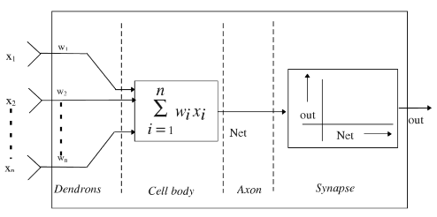

Figure An electrical equivalent of the biological neuron

Abstraction comes naturally to the human brain. Neural networks have to work for it. As with the brain, neural networks are made of building blocks called “neurons” that are connected in various ways. (The neurons in a neural network are inspired by neurons in the brain but do not imitate them directly.) Each neuron might represent an attribute, or a combination of attributes, that the network considers at each level of abstraction.

When joining these neurons together, engineers have many choices to make. They have to decide how many layers of neurons the network should have (or how “deep” it should be). Consider, for example, a neural network with the task of recognizing objects in images. The image enters the system at the first layer. At the next layer, the network might have neurons that simply detect edges in the image. The next layer combines lines to identify curves in the image. Then the next layer combines curves into shapes and textures, and the final layer processes shapes and textures to reach a conclusion about what it’s looking at: woolly mammoth!

So, if you have a specific task in mind, how do you know which neural network architecture will accomplish it best? There are some broad rules of thumb. For image-related tasks, engineers typically use “convolutional” neural networks, which feature the same pattern of connections between layers repeated over and over. For natural language processing — like speech recognition, or language generation — engineers have found that “recurrent” neural networks seem to work best. In these, neurons can be connected to non-adjacent layers.

Researchers today describe wide, flat networks as “expressive,” meaning that they’re capable in theory of capturing a richer set of connections between possible inputs (such as an image) and outputs (such as descriptions of the image). Yet these networks are extremely difficult to train, meaning it’s almost impossible to teach them how to actually produce those outputs. They’re also more computationally intensive than any computer can handle. (Harnett, 2019)

## The application areas in which ANNs have been successful in delivering human-like performance

Artificial neural networks (ANNs) were inspired by information processing and distributed communication nodes in biological systems. ANNs have various differences from biological brains. Specifically, neural networks tend to be static and symbolic, while the biological brain of most living organisms is dynamic (plastic) and analog. ANNs have given rise to Deep Learning, which is a broader view of ANNs, the performance benefits of DNNs are just phenomenal, which only caveat that DNNs require huge amounts of data.

1. Self-Driving Cars

The last decade witnessed increasingly rapid progress in self-driving vehicle technology, mainly backed up by advances in the area of deep learning and artificial intelligence. Self-driving cars are autonomous decision-making systems that process streams of observations coming from different on-board sources, such as cameras, radars, LiDARs, ultrasonic sensors, GPS units and/or inertial sensors. These observations are used by the car’s computer to make driving decisions.

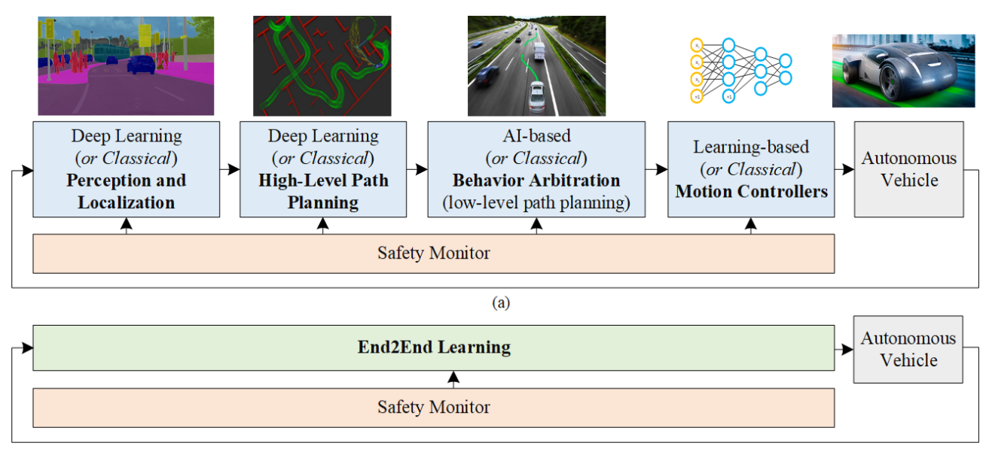

Figure Deep Learning based Self Driving Car

1. Pixel Restoration

The concept of zooming into videos beyond its actual resolution was unrealistic until Deep Learning came into play. In 2017, Google Brain researchers trained a Deep Learning network to take very low resolution images of faces and predict the person’s face through it. This method was known as the Pixel Recursive Super Resolution. It enhances the resolution of photos significantly, pinpointing prominent features in order that is just enough for personality identification.

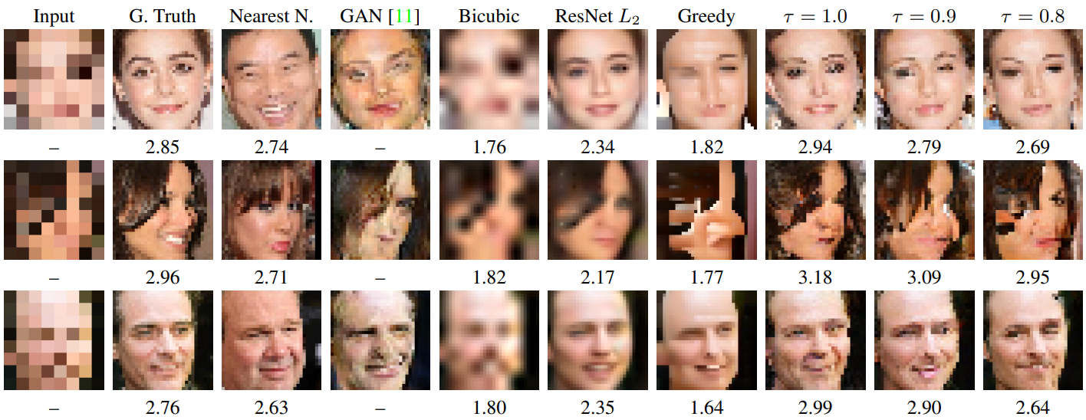

Figure Pixel Restoration

1. Adding Sound to Images

An application of both convolutional neural networks and LSTM recurrent neural networks involves synthesizing sounds to match silent videos. A deep learning model tends to associate the video frames with a database of pre-recorded sounds to select appropriate sounds for the scene. This task is done using training 1000 videos – that have drum sticks sound striking on different surfaces and creating different sounds. These videos are then used by Deep learning models to predict the best suited sound in the video. And later to predict if the sound is fake or real, a Turing-test like setup is built to achieve the best results.

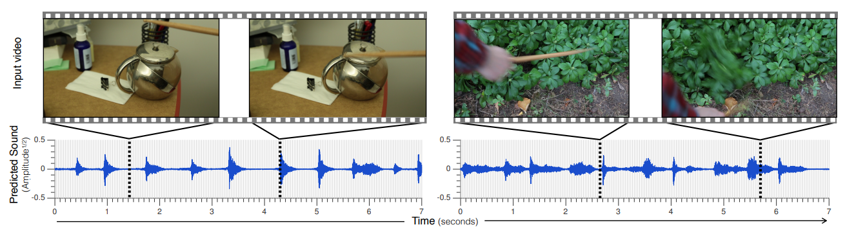

1. Image Caption Generation

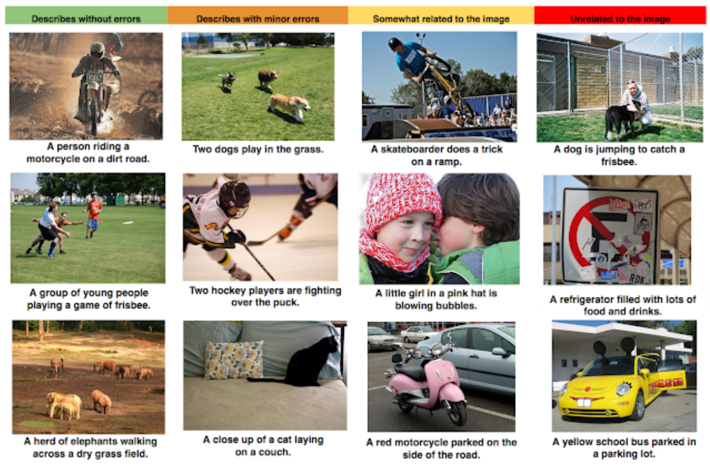Automatic image captioning is the task where given an image the system must generate a caption that describes the contents of the image. Generally, the systems involve the use of very large convolutional neural networks for the object detection in the photographs and then a recurrent neural network like an LSTM to turn the labels into a coherent sentence.

1. Machine Translation

The technology behind Google Translate is called Machine Translation. It has changed the world by allowing people to communicate when it wouldn’t otherwise be possible. It turns out that over the past two years, deep learning has totally rewritten our approach to machine translation. Deep learning researchers who know almost nothing about language translation are throwing together relatively simple machine learning solutions that are beating the best expert-built language translation systems in the world.

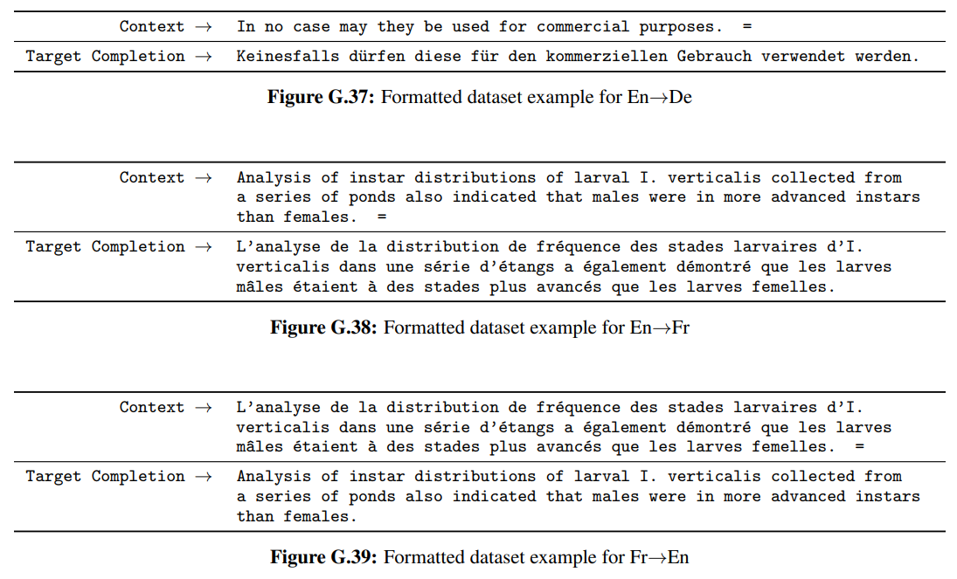

Figure Machine Translation example from GPT3

## Conclusion

With the way AI and machine learning is being adopted by companies today, we could see more advancements in the applications of neural networks. There will be personalized choices for users all over the world. All mobile and web applications try to give you an enhanced customized experience based on your search history. Hyper-intelligent virtual assistants will make life easier. If you have ever used Google assistant, Siri, or any of those assistants, you can comprehend how they're slowly evolving. They may even predict your email response in the future.

We can expect a few intriguing discoveries on algorithms to support learning methods. We are just in the infant stage of applying artificial intelligence and neural networks to the real world. Neural networks will be a lot faster in the future, and neural network tools can get embedded in every design surface. We already have a little mini neural network that plugs into an inexpensive processing board, or even into your laptop. Focusing on the hardware, instead of the software, would make devices even faster.

Neural networks will find its usage in the field of medicine, agriculture, physics, discoveries, and everything else you can imagine. Neural networks are also used in shared data systems.

# Question 2

Solution to Question 1 Part B

## A model of generalized fuzzy decision system for project evaluation

Pandey et al. (2015) proposed a fuzzy logic based grading system for student projects using quality attributes, most of this assignment is inspired from their proposed solution.

But first, we build the whole pipeline of how the whole system would work,

Fuzzy logic is branch of logic specially designed for representing knowledge and human reasoning in such a way that it amenable to processing by a computer. Fuzziness pertains to uncertainty associated with a system i.e. the fact that nothing can be predicted with exact precision. Fuzziness is property of language. Its main source is the imprecision in defining and using symbol. A fuzzy set is a collection of distinct elements with a varying degree of relevance or inclusion. There are two commonly used ways of denoting fuzzy sets. **(Pandey et al, 2015)**

A fuzzy variable has a crisp value which takes on some number over a pre-defined domain (in fuzzy logic terms, called a universe). The crisp value is how we think of the variable using normal mathematics. For example, if my fuzzy variable was how much to tip someone, it’s universe would be 0 to 25% and it might take on a crisp value of 15%.

If $X$ is the Universe of discourse and $x$ is a particular element of $X$, then a fuzzy set $A$ defined on $X$ may be written as a collection of ordered pairs:

$$A=\left\{\left(x, μ_{A}(A)\right)\right\}, x∈X$$

Where each pair $\left(x, μ_{A}(A)\right)$ is called a singleton, where $x$ is followed by its membership function $μ_{A}(A)$,

Singleton can also be written as $μ_{A}(x)/x$ and fuzzy set $A$ can also be represented as.

$$A=\sum_{x_{i}}{\frac{x_{i}}{μ_{A}(x_{i})}}$$

Membership function also known as characteristic function can take value between 0 and 1 and indicates degree of membership. Since there are infinite numbers between 0 and 1, infinite degrees of membership are possible.

For this assignment, we need to create a generalized system for project evaluation, where students show their project with their project report, and power point presentation. Experts judge on different criteria, and assign an opinion as a linguistic term (excellent, very good, good, average or bad). Their opinion has to be combined for grading the project.

To solve this, first a set of project attributes are selected, and their possible linguistic terms are selected. A fuzzy decision set is formed which indicate expert opinion for each project attributes. Fuzzy set is then defined for each attribute. A fuzzy subset is formed for all linguistic terms. For example, presentation can be Excellent, Very Good, Good, Average, Fair or Bad. Similarly, Modularity can be High, Medium, Low, Very Low or Nil.

Following are the attributes and their linguistic terms used to denote the evaluation of a student project,

1. Documentation
   1. Excellent (E)
   2. Very Good (VG)
   3. Satisfying (S)
   4. Moderate (D)
   5. Limited (L)
   6. Bad (B)
2. Presentation
   1. Excellent (E)
   2. Very Good (VG)
   3. Good (G)
   4. Average (AV)
   5. Fair (F)
   6. Bad (B)
3. Security/Authentication
   1. Excellent (E)
   2. Very Good (VG)
   3. Good (G)
   4. Average (AV)
   5. Fair (F)
   6. Bad (B)
4. Functionality
   1. Excellent (E)
   2. Very Good (VG)
   3. Good (G)
   4. Average (AV)
   5. Fair (F)
   6. Bad (B)
5. Modularity
   1. Very High (VH)
   2. High (H)
   3. Medium (M)
   4. Low (L)
   5. Very Low (VL)
   6. Nil (N)
6. Design of User Interface
   1. Excellent (E)
   2. Very Good (VG)
   3. Good (G)
   4. Average (AV)
   5. Fair (F)
   6. Bad (B)

Now that these linguistic terms are fixed, we can assign a membership function to each of them, i.e. the fuzzy subset representation to them. Further we will proceed by creating a logic of how to aggregate these opinions into numeric values and then defuzzify the value to assign a final grade to the student like Ex, A+, A, B, B+, or C.

## Fuzzy sets with attributes

Following are the six attributes and considerable corresponding linguistic terms that are selected for project evaluation along with their fuzzy subsets:

1. Documentation
   1. Excellent (E): 1/1.0+2/0.8+3/0.6+4/0.4+5/0.2+6/0.0
   2. Very Good (VG): 1/0.8+2/1.0+3/0.8+4/0.6+5/0.4+6/0.2
   3. Satisfying (S): 1/0.6+2/0.8+3/1.0+4/0.8+5/0.6+6/0.4
   4. Moderate (D): 1/0.4+2/0.6+3/0.8+4/1.0+5/0.8+6/0.6
   5. Limited (L): 1/0.2+2/0.4+3/0.6+4/0.8+5/1.0+6/0.8
   6. Bad (B): 1/0.0+2/0.2+3/0.4+4/0.6+5/0.8+6/1.0

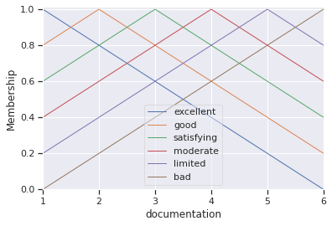

1. Presentation
   1. Excellent (E): 1/1.0+2/0.8+3/0.6+4/0.4+5/0.2+6/0.0
   2. Very Good (VG): 1/0.8+2/1.0+3/0.8+4/0.6+5/0.4+6/0.2
   3. Good (G): 1/0.6+2/0.8+3/1.0+4/0.8+5/0.6+6/0.4
   4. Average (AV): 1/0.4+2/0.6+3/0.8+4/1.0+5/0.8+6/0.6
   5. Fair (F): 1/0.2+2/0.4+3/0.6+4/0.8+5/1.0+6/0.8
   6. Bad (B): 1/0.0+2/0.2+3/0.4+4/0.6+5/0.8+6/1.0

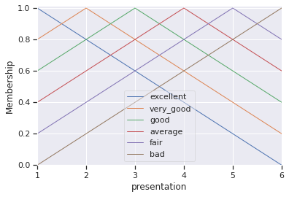

1. Security/Authentication
   1. Excellent (E): 1/1.0+2/0.8+3/0.6+4/0.4+5/0.2+6/0.0
   2. Very Good (VG): 1/0.8+2/1.0+3/0.8+4/0.6+5/0.4+6/0.2
   3. Good (G): 1/0.6+2/0.8+3/1.0+4/0.8+5/0.6+6/0.4
   4. Average (AV): 1/0.4+2/0.6+3/0.8+4/1.0+5/0.8+6/0.6
   5. Fair (F): 1/0.2+2/0.4+3/0.6+4/0.8+5/1.0+6/0.8
   6. Bad (B): 1/0.0+2/0.2+3/0.4+4/0.6+5/0.8+6/1.0

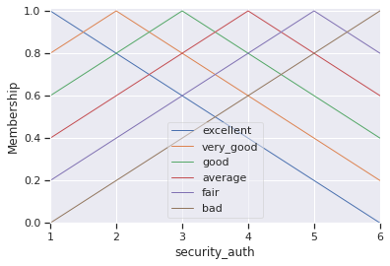

1. Functionality
   1. Excellent (E): 1/1.0+2/0.8+3/0.6+4/0.4+5/0.2+6/0.0
   2. Very Good (VG): 1/0.8+2/1.0+3/0.8+4/0.6+5/0.4+6/0.2
   3. Good (G): 1/0.6+2/0.8+3/1.0+4/0.8+5/0.6+6/0.4
   4. Average (AV): 1/0.4+2/0.6+3/0.8+4/1.0+5/0.8+6/0.6
   5. Fair (F): 1/0.2+2/0.4+3/0.6+4/0.8+5/1.0+6/0.8
   6. Bad (B): 1/0.0+2/0.2+3/0.4+4/0.6+5/0.8+6/1.0

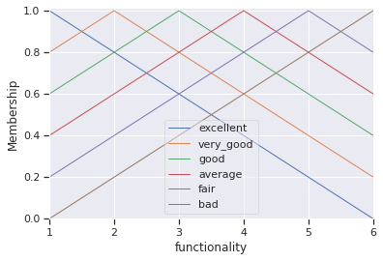

1. Modularity
   1. Very High (VH): 1/1.0+2/0.8+3/0.6+4/0.4+5/0.2+6/0.0
   2. High (H): 1/0.8+2/1.0+3/0.8+4/0.6+5/0.4+6/0.2
   3. Medium (M): 1/0.6+2/0.8+3/1.0+4/0.8+5/0.6+6/0.4
   4. Low (L): 1/0.4+2/0.6+3/0.8+4/1.0+5/0.8+6/0.6
   5. Very Low (VL): 1/0.2+2/0.4+3/0.6+4/0.8+5/1.0+6/0.8
   6. Nil (N): 1/0.0+2/0.2+3/0.4+4/0.6+5/0.8+6/1.0

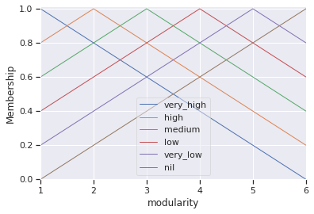

1. Design of User Interface
   1. Excellent (E): 1/1.0+2/0.8+3/0.6+4/0.4+5/0.2+6/0.0
   2. Very Good (VG): 1/0.8+2/1.0+3/0.8+4/0.6+5/0.4+6/0.2
   3. Good (G): 1/0.6+2/0.8+3/1.0+4/0.8+5/0.6+6/0.4
   4. Average (AV): 1/0.4+2/0.6+3/0.8+4/1.0+5/0.8+6/0.6
   5. Fair (F): 1/0.2+2/0.4+3/0.6+4/0.8+5/1.0+6/0.8
   6. Bad (B): 1/0.0+2/0.2+3/0.4+4/0.6+5/0.8+6/1.0

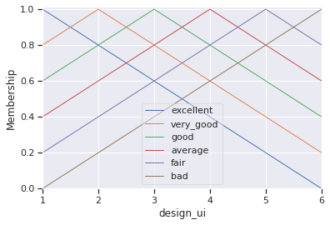

## Dataset (test cases) generation

Note: Some of the not-so-important code is omitted, to view the entire code, refer Appendix

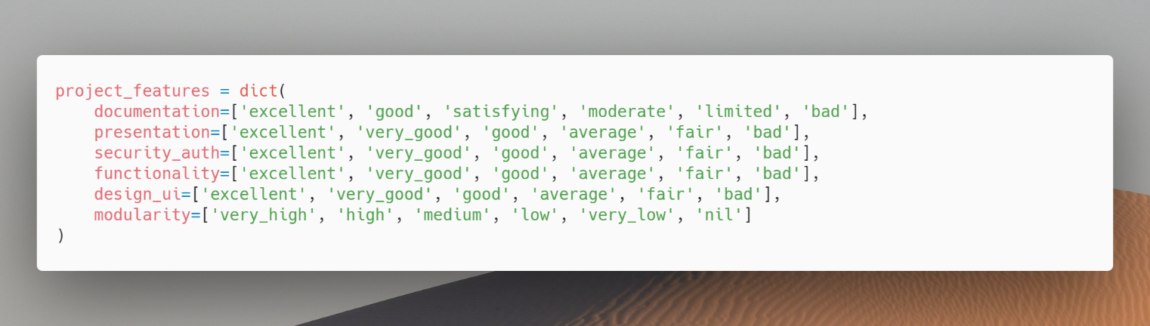We first define our project attributes, so that it can easily be referenced at later parts of our program

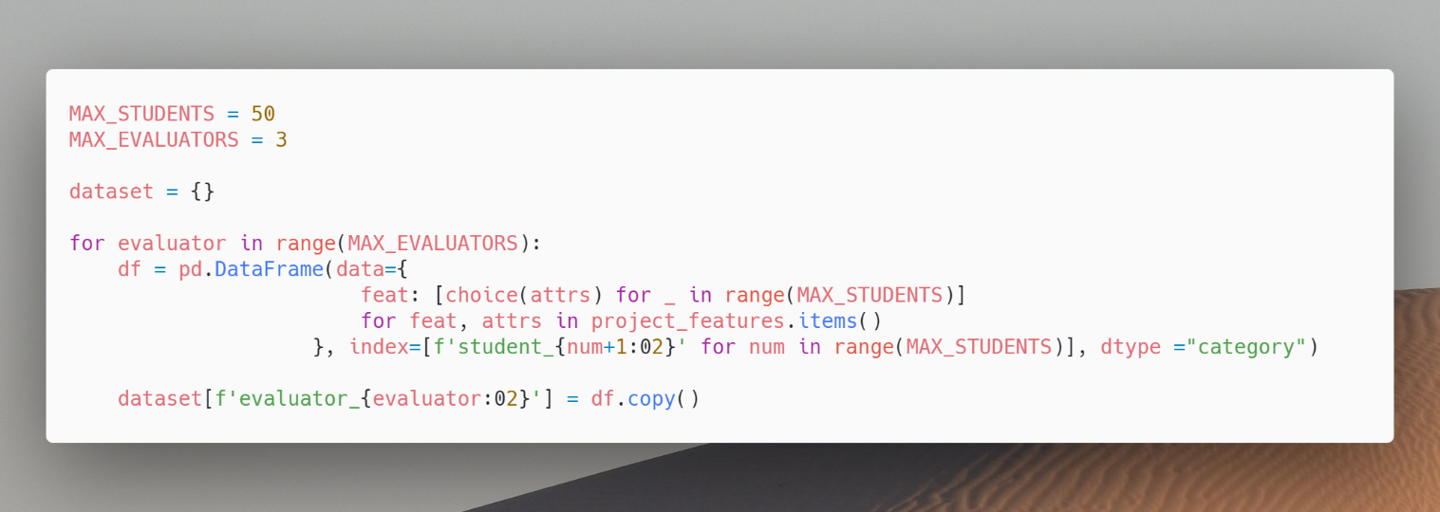

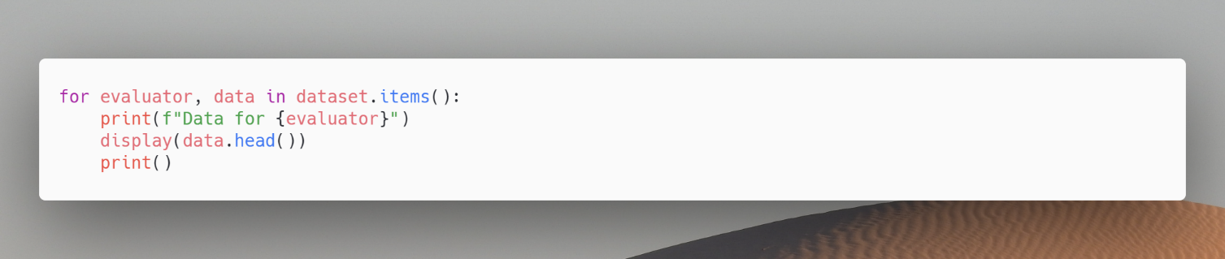Now we can print the dataset and visualize the table

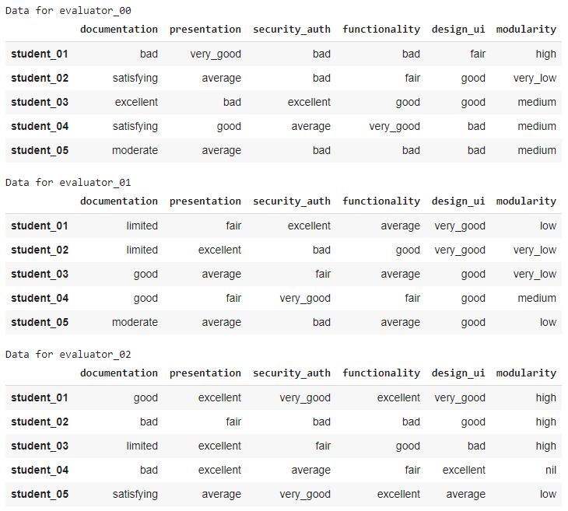

The above is the first 5 samples of each of the evaluators, in total we have 3 evaluators and 50 students, that is in total of 50 test case (each student = one test case).

## Fuzzy Logic System Creation

We’ll be using skfuzzy, an easy to use fuzzy logic library for python. Each of our attribute (document, design …) needs a fuzzy set with it, and for that we require a membership function, this membership function can be created using the fuzzy set values we defined earlier.

Following is a helper function that converts the fuzzy set values into 3 points that define a triangular membership function.

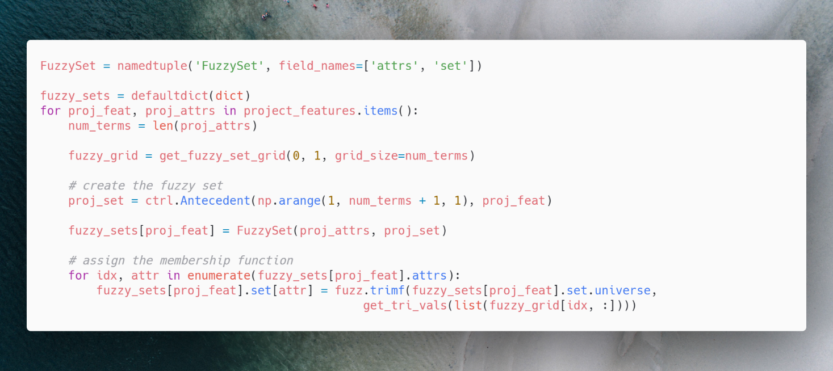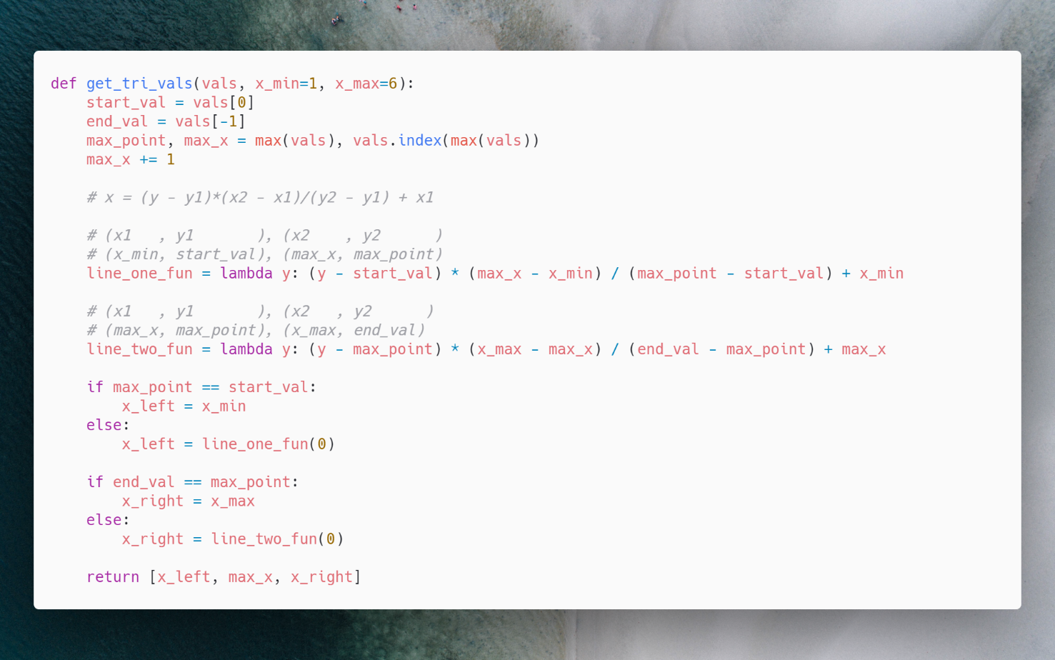

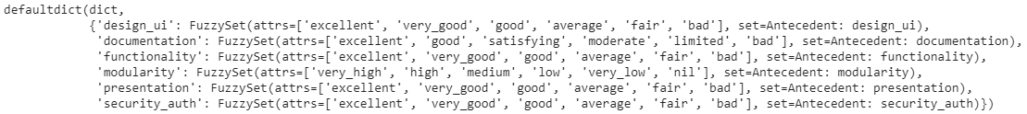

Also, we can view the membership functions,

|  |  |
| --- | --- |
|  |  |
|  |  |
|  |  |

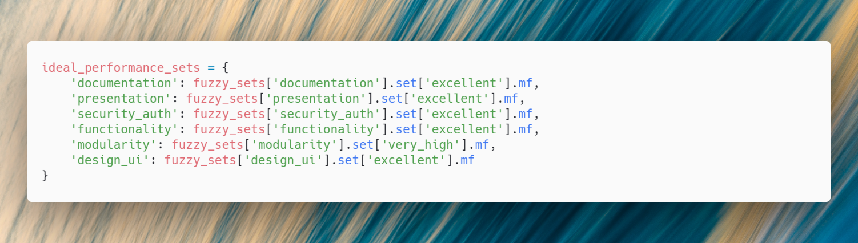Now we define the ideal performance of each of them,

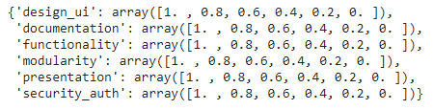

## Evaluating Student Performance

A panel of 3 evaluators are formed that evaluate each of the student performance based on our 6 criteria, these evaluators state their opinion linguistically, and an opinion matrix is formed based on that.

We can demonstrate how this happens, consider the following student, with evaluation for 6 criteria by 3 evaluators,

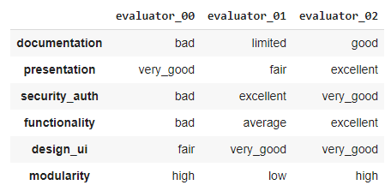

For each of the linguistic value, we get the membership value, and compare the distance from the “ideal” performance we defined before,

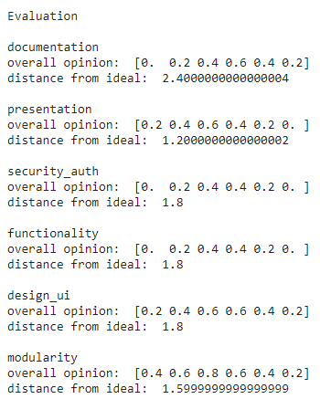

$$documentation= bad \bigwedge{limited}\bigwedge{good} \\ presentation=very good \bigwedge{fair}\bigwedge{excellent} \\ security auth=bad\bigwedge{excellent}\bigwedge{very good} \\ functionality=bad\bigwedge{average\bigwedge{excellent}} \\ design ui=fair\bigwedge{very good\bigwedge{very good}} \\ modularity=high \bigwedge{low \bigwedge{high}}$$

And the distance from ideal is calculated as,



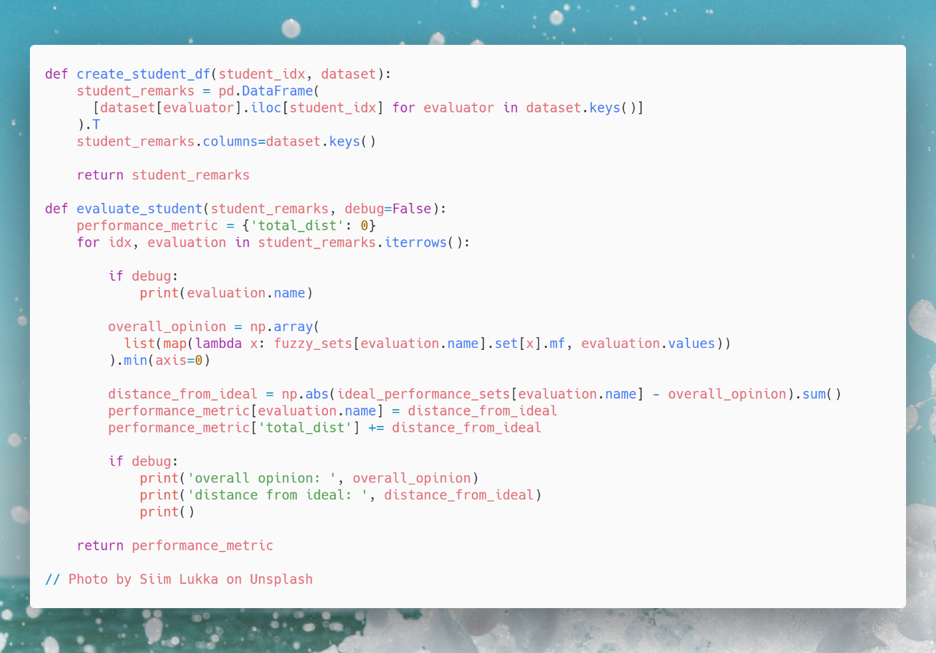Using this logic, we apply it on all of the students in the dataset,

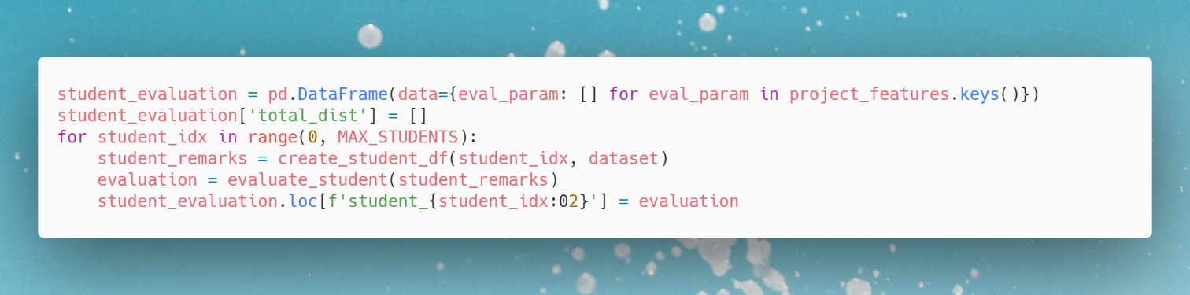

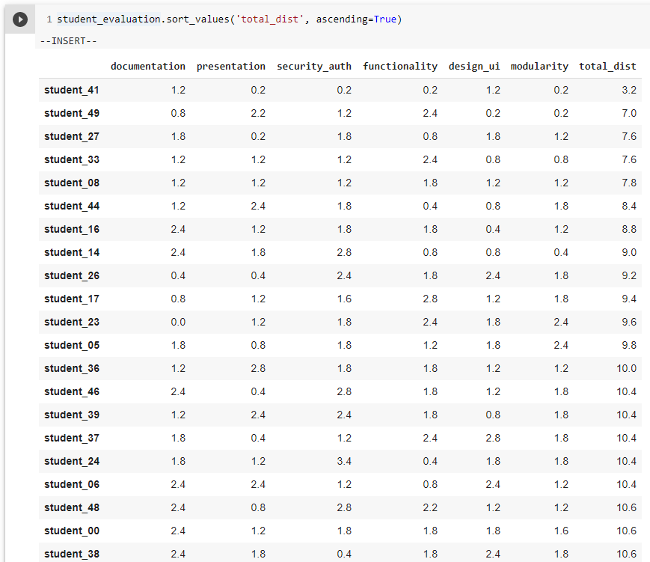

For grading we choose 6 grades,

* **Ex**: Equivalent to Excellent of Documentation, Presentation, Security, Functionality and User Interface and Very High of Modularity
* **A+**: Equivalent to Good of Documentation, Very Good of Presentation, Security, Functionality and User Interface, and High of Modularity
* **A**: Equivalent to Satisfying of Documentation, Good of Presentation, Security, Functionality and User Interface, and Medium of Modularity
* **B**: Equivalent of Moderate of Documentation, Average of Presentation, Security, Functionality and User Interface, and Low of Modularity
* **B+**: Equivalent of Limited of Documentation, Moderate of Presentation, Security, Functionality and User Interface, and Very Low of Modularity
* **C**: Equivalent of Bad of Documentation, Presentation, Security, Functionality and User Interface and Nil of Modularity

Now we compute the distance of Ex and other grades,

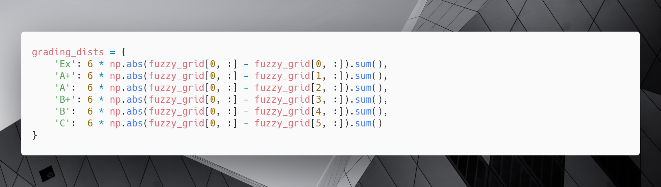

Here, the FuzzyGrid is as follows,

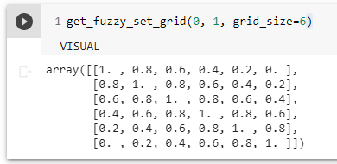

And the grading distance matrix is,

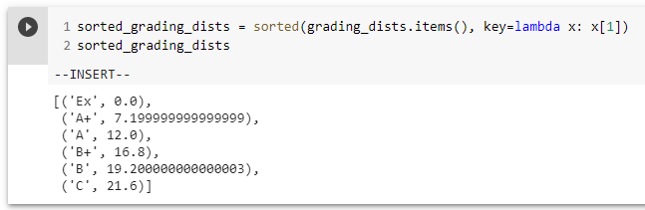

So,

IF total < 7.19 THEN grade = Ex

IF total >= 7.19 AND total < 12.00 THEN grade = A+

IF total >= 12.0 AND total < 16.80 THEN grade = A

IF total >= 16.80 AND total < 19.20 THEN grade = B+

IF total >= 19.20 AND total < 21.60 THEN grade = B

IF total >= 21.60 THEN grade = C

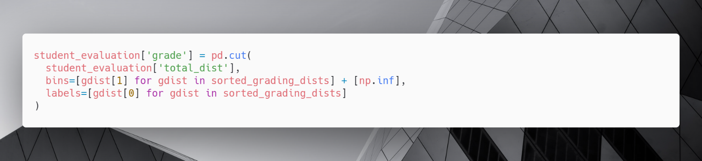We can apply the above logic in our dataset as,

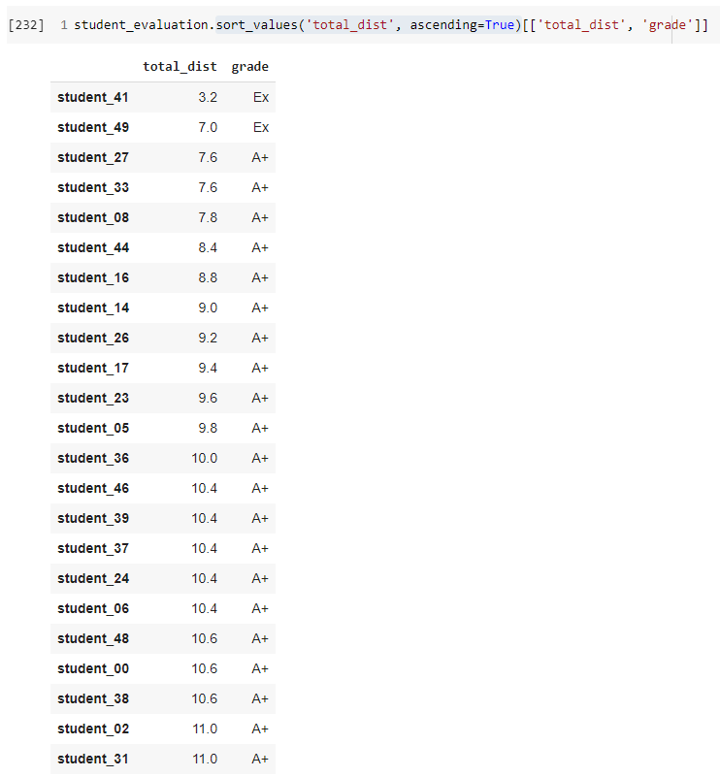

The above figure shows the total distance of the student from idea, and also the grade assigned to them based on the distance, lower the distance, higher the grade.

Refer to Results and Conclusion in this Assignment to see the grade of all the 50 students.

## Results

|  |  |  |  |  |  |  |  |  |
| --- | --- | --- | --- | --- | --- | --- | --- | --- |
|  | **document-**  **tation** | **present-ation** | **security-**  **auth** | **function-ality** | **design-**  **ui** | **modular-ity** | **total**  **dist** | **grade** |
| **student_41** | 1.2 | 0.2 | 0.2 | 0.2 | 1.2 | 0.2 | 3.2 | Ex |
| **student_49** | 0.8 | 2.2 | 1.2 | 2.4 | 0.2 | 0.2 | 7 | Ex |
| **student_27** | 1.8 | 0.2 | 1.8 | 0.8 | 1.8 | 1.2 | 7.6 | A+ |
| **student_33** | 1.2 | 1.2 | 1.2 | 2.4 | 0.8 | 0.8 | 7.6 | A+ |
| **student_08** | 1.2 | 1.2 | 1.2 | 1.8 | 1.2 | 1.2 | 7.8 | A+ |
| **student_44** | 1.2 | 2.4 | 1.8 | 0.4 | 0.8 | 1.8 | 8.4 | A+ |
| **student_16** | 2.4 | 1.2 | 1.8 | 1.8 | 0.4 | 1.2 | 8.8 | A+ |
| **student_14** | 2.4 | 1.8 | 2.8 | 0.8 | 0.8 | 0.4 | 9 | A+ |
| **student_26** | 0.4 | 0.4 | 2.4 | 1.8 | 2.4 | 1.8 | 9.2 | A+ |
| **student_17** | 0.8 | 1.2 | 1.6 | 2.8 | 1.2 | 1.8 | 9.4 | A+ |
| **student_23** | 0 | 1.2 | 1.8 | 2.4 | 1.8 | 2.4 | 9.6 | A+ |
| **student_05** | 1.8 | 0.8 | 1.8 | 1.2 | 1.8 | 2.4 | 9.8 | A+ |
| **student_36** | 1.2 | 2.8 | 1.8 | 1.8 | 1.2 | 1.2 | 10 | A+ |
| **student_46** | 2.4 | 0.4 | 2.8 | 1.8 | 1.2 | 1.8 | 10.4 | A+ |
| **student_39** | 1.2 | 2.4 | 2.4 | 1.8 | 0.8 | 1.8 | 10.4 | A+ |
| **student_37** | 1.8 | 0.4 | 1.2 | 2.4 | 2.8 | 1.8 | 10.4 | A+ |
| **student_24** | 1.8 | 1.2 | 3.4 | 0.4 | 1.8 | 1.8 | 10.4 | A+ |
| **student_06** | 2.4 | 2.4 | 1.2 | 0.8 | 2.4 | 1.2 | 10.4 | A+ |
| **student_48** | 2.4 | 0.8 | 2.8 | 2.2 | 1.2 | 1.2 | 10.6 | A+ |
| **student_00** | 2.4 | 1.2 | 1.8 | 1.8 | 1.8 | 1.6 | 10.6 | A+ |
| **student_38** | 2.4 | 1.8 | 0.4 | 1.8 | 2.4 | 1.8 | 10.6 | A+ |
| **student_02** | 1.2 | 1.8 | 1.2 | 2.2 | 2.8 | 1.8 | 11 | A+ |
| **student_31** | 3.2 | 0.4 | 2.4 | 1.8 | 0.8 | 2.4 | 11 | A+ |
| **student_42** | 1.8 | 1.2 | 2.4 | 2.8 | 2.4 | 0.4 | 11 | A+ |
| **student_11** | 2.2 | 2.8 | 0.4 | 2.4 | 0.8 | 2.4 | 11 | A+ |
| **student_35** | 1.8 | 2.8 | 1.2 | 1.2 | 0.8 | 3.4 | 11.2 | A+ |
| **student_19** | 0.4 | 1.8 | 1.6 | 3.4 | 1.8 | 2.4 | 11.4 | A+ |
| **student_34** | 3.2 | 1.2 | 0.2 | 1.2 | 2.4 | 3.2 | 11.4 | A+ |
| **student_13** | 1.6 | 0.8 | 2.4 | 1.8 | 1.6 | 3.2 | 11.4 | A+ |
| **student_03** | 2.4 | 1.2 | 1.6 | 1.8 | 1.8 | 2.8 | 11.6 | A+ |
| **student_10** | 1.2 | 1.8 | 2.4 | 1.8 | 2.4 | 2.4 | 12 | A |
| **student_12** | 2.4 | 2.4 | 1.8 | 1.8 | 1.8 | 1.8 | 12 | A |
| **student_28** | 0.2 | 2.8 | 2.4 | 2.4 | 1.8 | 2.4 | 12 | A |
| **student_45** | 2.4 | 3.4 | 2.4 | 1.2 | 1.8 | 0.8 | 12 | A |
| **student_21** | 1.8 | 2.8 | 1.8 | 1.8 | 0.8 | 3.2 | 12.2 | A |
| **student_29** | 1.2 | 2.8 | 1.8 | 0.8 | 2.8 | 2.8 | 12.2 | A |
| **student_07** | 1.2 | 2.8 | 1.2 | 2.8 | 1.8 | 2.4 | 12.2 | A |
| **student_30** | 1.8 | 2.4 | 3.2 | 3.4 | 1.2 | 0.4 | 12.4 | A |
| **student_20** | 1.2 | 1.2 | 3.2 | 1.2 | 2.4 | 3.2 | 12.4 | A |
| **student_22** | 0.4 | 1.8 | 2.4 | 1.8 | 3.2 | 2.8 | 12.4 | A |
| **student_40** | 3.2 | 1.2 | 1.2 | 1.8 | 2.4 | 2.8 | 12.6 | A |
| **student_09** | 3.4 | 1.8 | 2.4 | 3.2 | 1.2 | 0.8 | 12.8 | A |
| **student_15** | 2.4 | 2.2 | 2.8 | 0.8 | 1.8 | 2.8 | 12.8 | A |
| **student_32** | 1.8 | 3.4 | 1.6 | 2.4 | 3.4 | 0.4 | 13 | A |
| **student_01** | 2.8 | 1.2 | 3.6 | 2.8 | 1.2 | 1.8 | 13.4 | A |
| **student_43** | 0.2 | 2.4 | 2.8 | 3.4 | 2.2 | 2.4 | 13.4 | A |
| **student_18** | 2.8 | 2.8 | 1.8 | 1.8 | 2.4 | 1.8 | 13.4 | A |
| **student_04** | 2.2 | 2.8 | 2.4 | 1.8 | 2.8 | 2.2 | 14.2 | A |
| **student_47** | 3.4 | 1.8 | 2.4 | 2.4 | 1.8 | 3.4 | 15.2 | A |
| **student_25** | 3.6 | 2.4 | 2.4 | 1.8 | 2 | 3.4 | 15.6 | A |

# Bibliography

1. Pandey, M., Srivastava, P.K. and Bhattacharjee, V., 2015. Fuzzy logic based grading system for student projects using quality attributes. International Journal of Engineering and Technology, 7, pp.1304-1308.
2. <https://github.com/scikit-fuzzy/scikit-fuzzy>
3. <https://www.quantamagazine.org/foundations-built-for-a-general-theory-of-neural-networks-20190131/>
4. <https://www.mygreatlearning.com/blog/deep-learning-applications/>
5. https://www.simplilearn.com/tutorials/deep-learning-tutorial/what-is-neural-network

# Appendix